

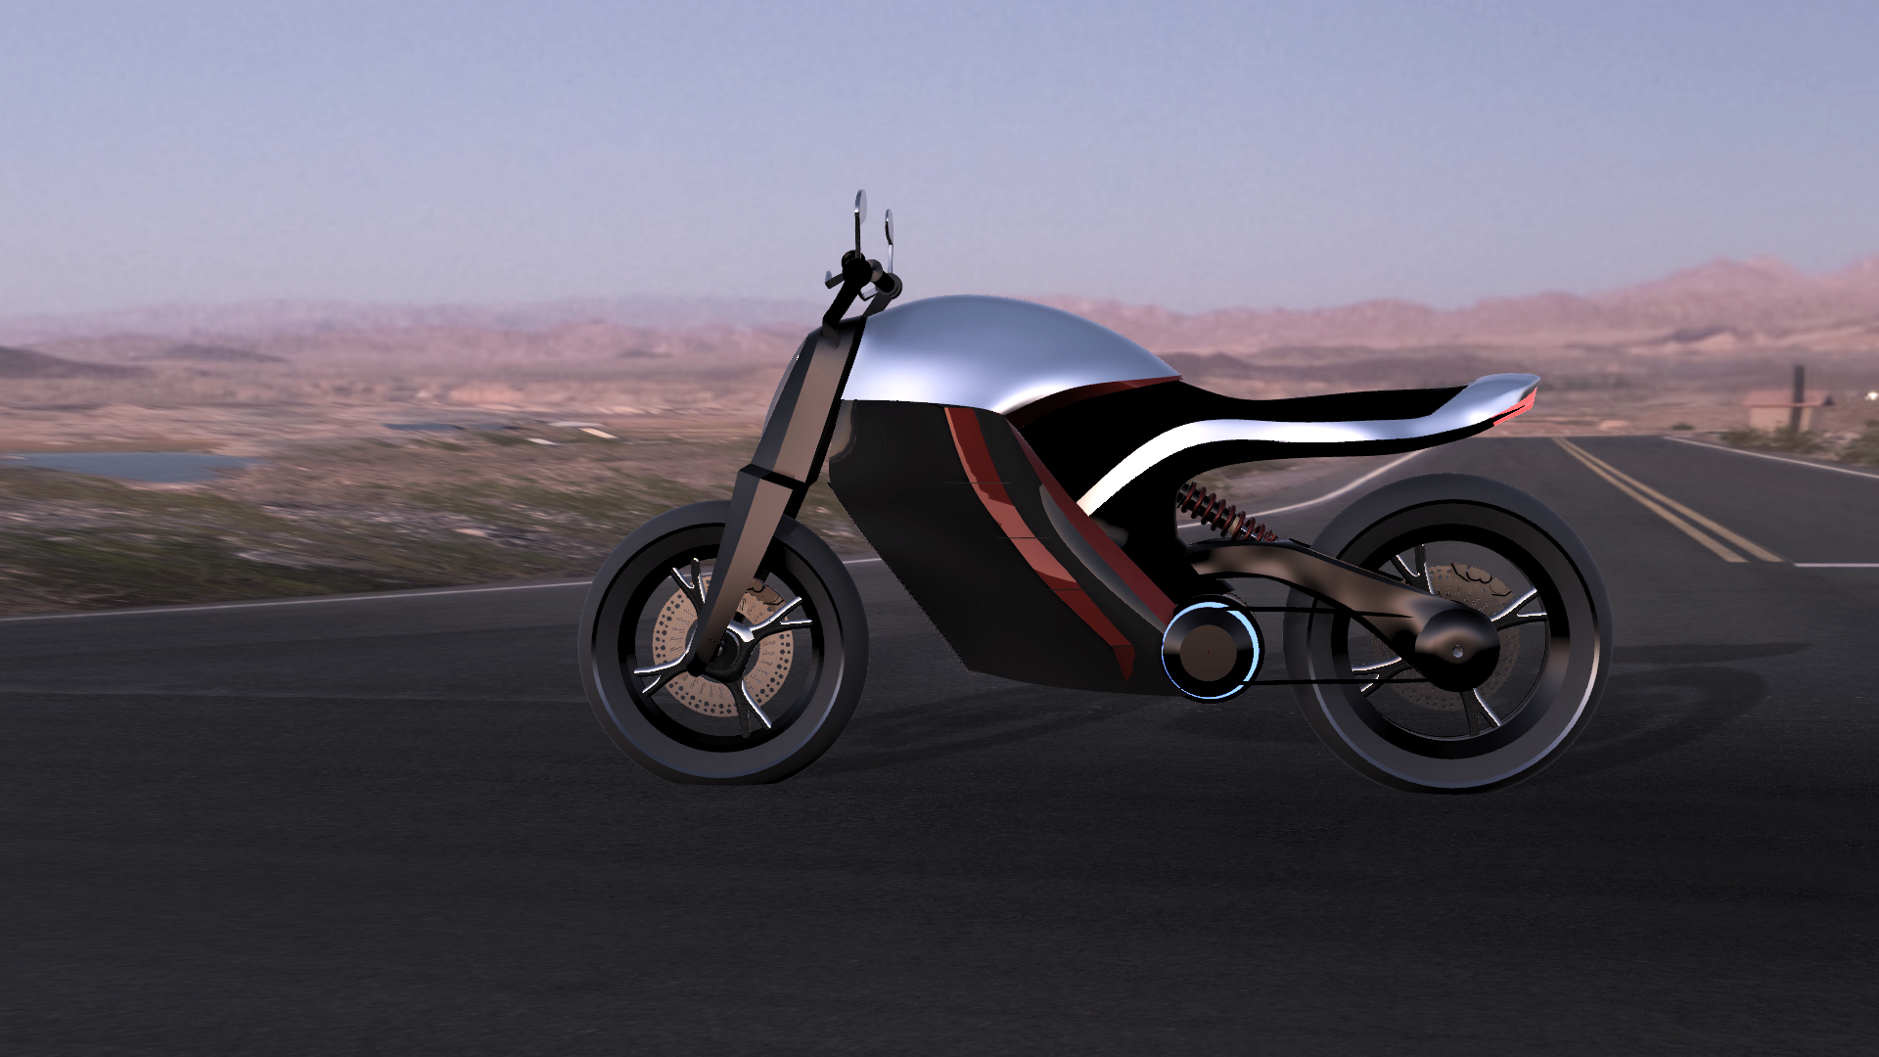

VISION-X

**Sustainable Transport**

***Mentors***

* Lalitha Anil
* Dr.Suresh
* Dr. Venugopal

**Table of Contents**

1. Introduction
2. Team Breakdown
3. Concept Design
4. Timeline
5. Simulation Summary
6. Battery
   1. Description
   2. Specifications of System
   3. Battery Pack
      1. Battery Chemistry
      2. Pack topology
   4. Thermal Management
      1. Cell housing
      2. Cooling solutions
   5. References
7. BMS
   1. Description
   2. Literature Review
      1. Battery Characteristics
      2. State of Charge
      3. Cell Balancing
   3. BMS Functions
   4. IC and PCB
   5. References
8. Charger
   1. Description
   2. Literature Review
      1. Battery Charger
      2. Charging Rates
      3. Conclusion
   3. Specifications of System
      1. Calculation of Specifications
      2. Specifications overview
   4. Boost converter
      1. Parts and specifications
      2. Schematic
      3. PCB
   5. Buck converter
      1. Parts and specifications
      2. Schematic
      3. PCB
   6. References
9. Motor Controller
   1. Description
   2. Literature Review
      1. Selection of Motor
      2. Controller Topology
      3. Conclusion
   3. Specifications of System
      1. Calculation of Specifications
      2. Specifications overview
   4. Inverter
      1. Parts and specifications
      2. Schematic
      3. PCB
   5. Driver
      1. Parts and specifications
      2. Schematic
      3. PCB
   6. MCU
      1. Source
   7. References
10. Chassis
11. Conclusion

Introduction

Objective

To build an end-to-end solution for sustainable transport. From energy generation like home solar roof solutions and charging stations to consumption in Electric Vehicles.

Act as a catalyst to the electrification of motor vehicles in India, and help accelerate India’s transition to Electric Vehicles under Vision 2030. Also enforce the MAKE IN INDIA campaign.

Incorporate new changes in a century old industry by building things **fundamentally better**

How we’re doing it

We’re starting off with the chicken in the chicken-egg problem, since a rudimentary “egg” exists.

A compelling cost effective performance all-electric motorbike with a strong visual presence, and focus on design in order to change people’s perception of electric vehicles and help accelerate the transition to EVs.

* **Future forward** - easy implementation of future technology
* **Modular**- Components can be swapped out as necessary
* **Augmented experience** - Redefine riding through AR
* **Clean Design** - Simple,elegant yet powerful and alluring, minimal life-cycle effect on environment.
* Majority **recyclable Parts** - Eco friendly in a true sense
* **Intelligent**- Improves performance with usage data

4W analysis (Why, when, where, who)

**India;** the second largest motorcycle (10.5 million produced in 2015 of a total of over 16.1 m two-wheelers) and the fourth largest commercial vehicle manufacturer in the world.

As of 2012 129.5 million 2 wheelers or 74.2% of motor vehicles were 2 wheelers

**Very mature market to make the most impact**

People in pioneering EV markets like US don't really use motorcycles that much. And those that do, are the loud Harley Davidson types so it makes sense.

Therefore, we are targeting developing markets, which predominantly consume and use a lot of 2 wheelers. Even places like Europe, where two wheelers are used extensively can be a market after proving quality and reliability and performance.

**India has NEMMP- national electric mobility mission 2020 which incentivizes EV’s and relevant infrastructure and Mission 2030 mandates only electric vehicles to be sold from 2030.**

Who we are

We are a team of college students who believe in making a difference and impact in the world right now, because a better future doesn’t build itself. We believe in **learning while** **doing**. **We believe in our vision**, and we will work as hard as we can until we achieve it.

We are based out of the “EV lab”, PES University, Bangalore. We are currently working with Eko vehicles, an Industry with a vast experience in the field of electric vehicles. We are also assisted by CORI (Crucible of Research and Innovation), a platform through which we have access to leading experts in fields including but not limited to Battery technology, Electricals and Electronics, Computer Science, Materials Science.

We have very tight deadlines, and we intend on achieving them. Our aim is to have a bike up and running as soon as July, and we are confident we will be successful.

**Carbon Zero Challenge**

* Carbon Zero Challenge (CZC) : Develop carbon neutral systems and grid-free infrastructure to serve five major sectors which are plagued by energy shortages/costs.
* Organised my IIT- Madras, and the US Consulate General
* The grand challenge:Develop a grid free alternative system which is economically viable, environment friendly, and easily replicable Urban housing, Transportation systems, Agriculture and Water and Waste management facilities.
* Open to students and/or early stage entrepreneurs of Tamil Nadu, Kerala, Karnataka, Pondicherry, and Andaman and Nicobar Islands.
* Preliminary round :
  + Online submissions
  + Maximum 25 teams selected
  + Provided with expert mentorship
  + Prototype funding upto Rs 5 lakhs per shortlisted project.
  + Final Prize Money: Rs 25 lakhs

Team Breakdown



Concept Design



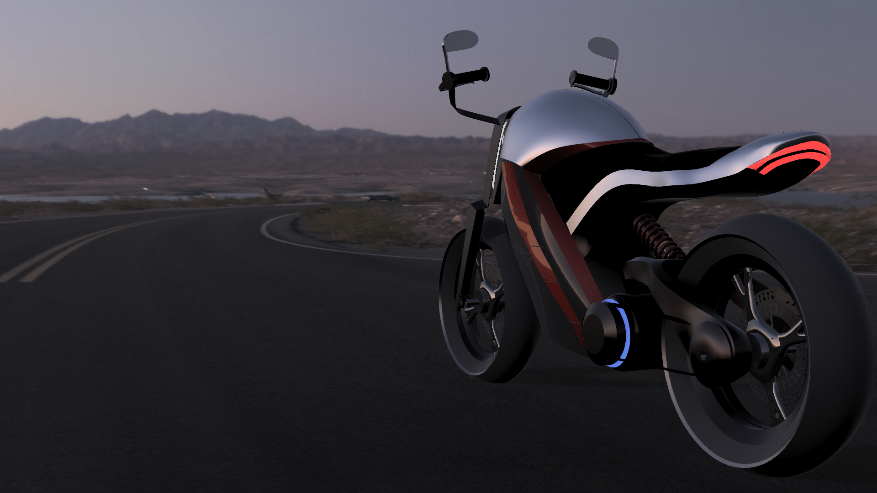

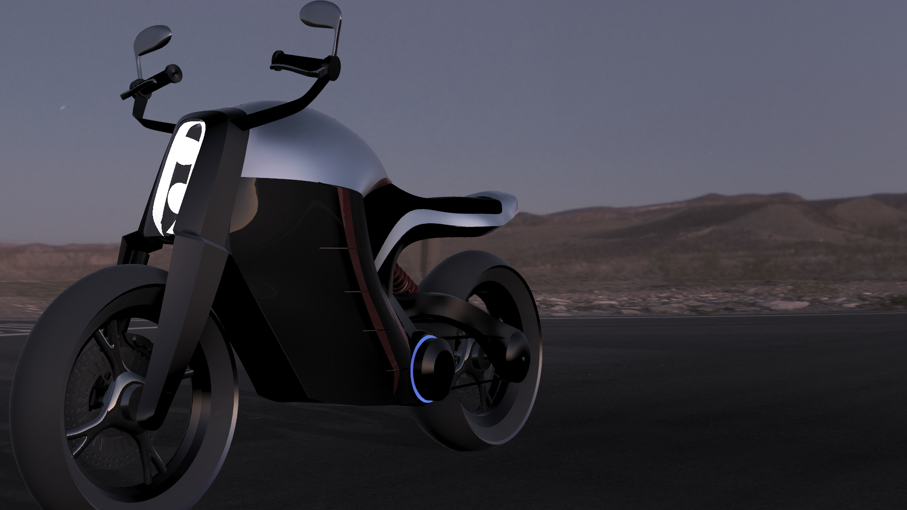

* Done on Autodesk Fusion 360 CAD/CAM + modelling software student license
* Concept renders meant for representation purposes only, to give an idea of the final product.
* Model will likely change with further developments

Timeline

|  | **Milestone/Task:** | **Timeline:** |
| --- | --- | --- |
| 1 | Research and Literature Study | 19/10/16 - 20/11/16 |
| 2 | Business Concept | 21/11/16 - 01/12/16 |
| 3 | Concept Design and Simulation | 01/12/16 - 01/02/17 |
| 4 | Prototype-Design | 01/02/17 - 01/6/17 |
| 5 | Prototype-Build | 24/06/17 - 30/07/17 |
| 6 | Prototype-testing | 01/08/17 - 30/08/17 |

Simulation Summary

**Procedure**

* Size up specifications of vehicle such as payload, performance, weight etc. after surveying market for preferable specifications of vehicle.
* Use physics based models to calculate power, torque and energy requirements over various drive cycles
* Use python scripts to simulate discrete time models of vehicle undergoing various drive-cycles
* Use results to arrive at optimum component specifications.

**Simulation Model**



**Preliminary Specifications of Vehicle**

* Top speed: 160 kmph
* Acceleration: 0-100 kmph in 7 sec
* Weight: 120 kg + 100 kg payload
* Range: 140 km
* Charge time: 1-2 hr
* Max incline: 30 degrees at full capacity

**Simulation Results**

Format of Graphs:

1. Drive cycle ( speed vs time) - provided by user/ statistics etc.
2. Power vs Time - vehicle power requirements as per drive cycle(DC)
3. Torque vs Time - torque requirements as per DC
4. Depth of Discharge of battery vs time - Depletion of Battery as per DC
5. Battery voltage vs time - Variation in battery Voltage as per DC
6. Drivetrain current vs time - Current draw by motor as per DC
7. Distance vs time - Distance travelled by vehicle as per DC

Constant speed: 15m/s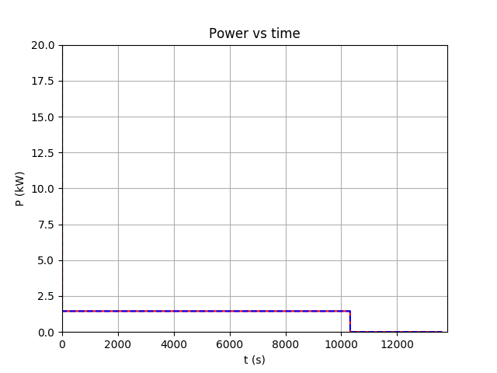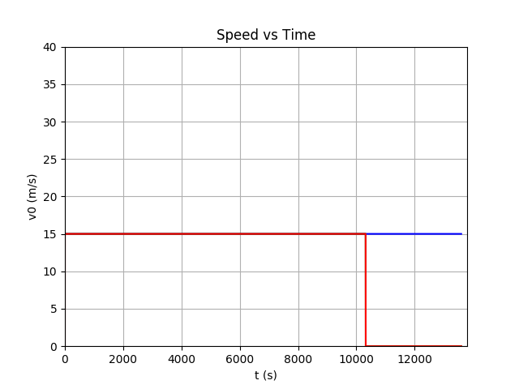

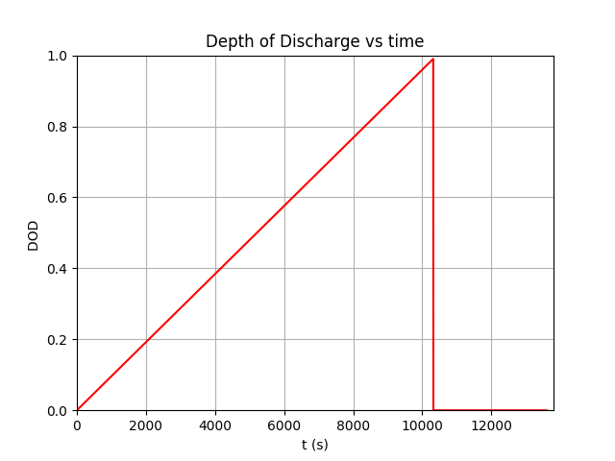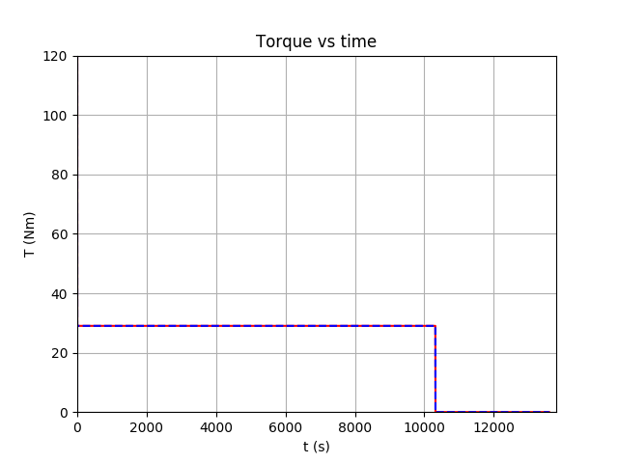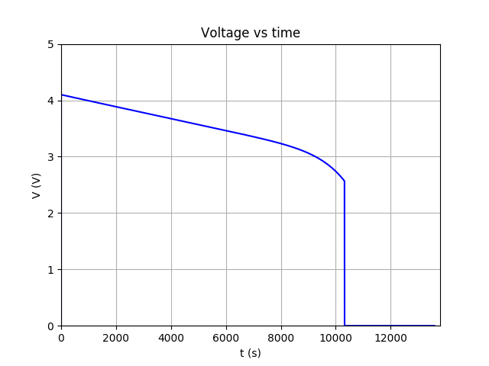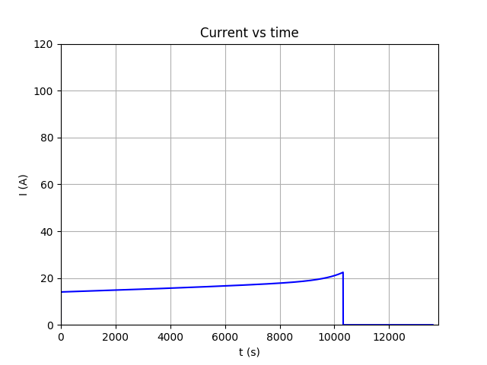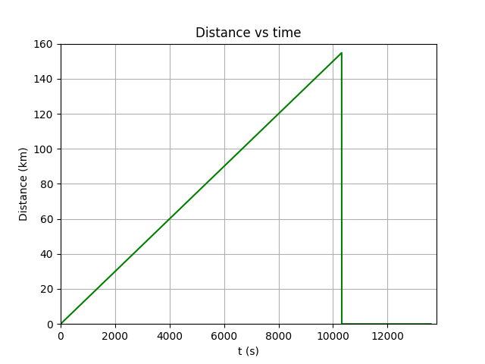

Drive Cycle: Urban

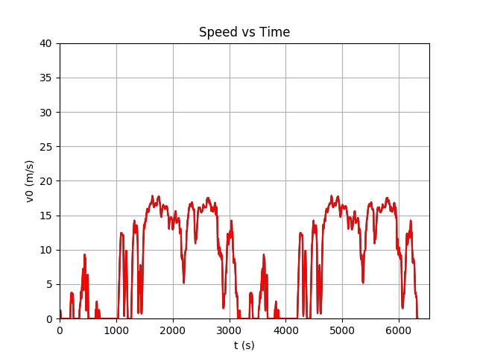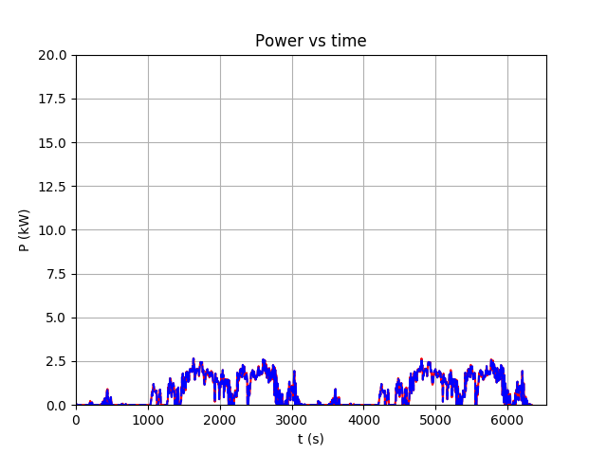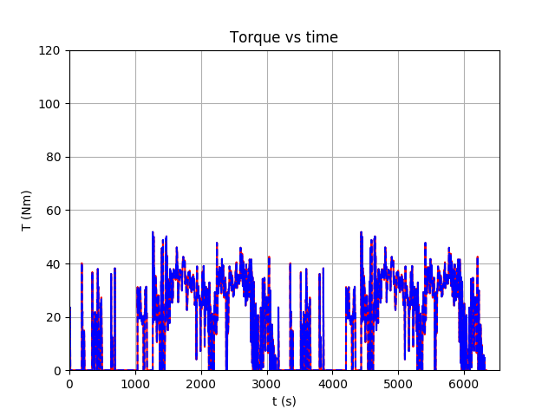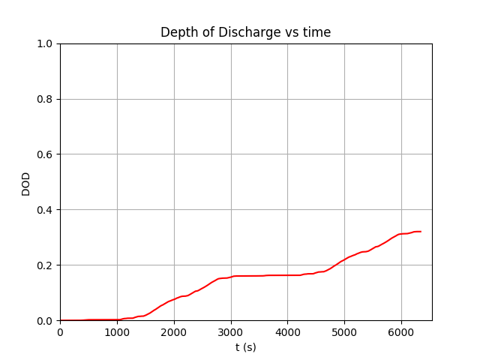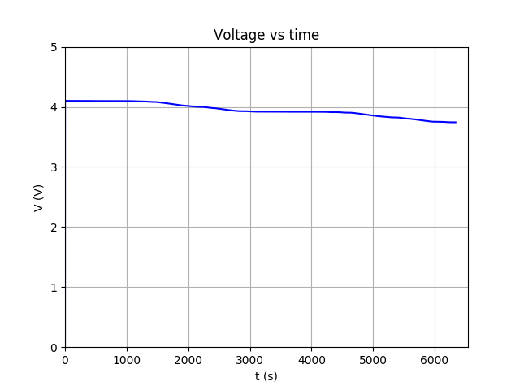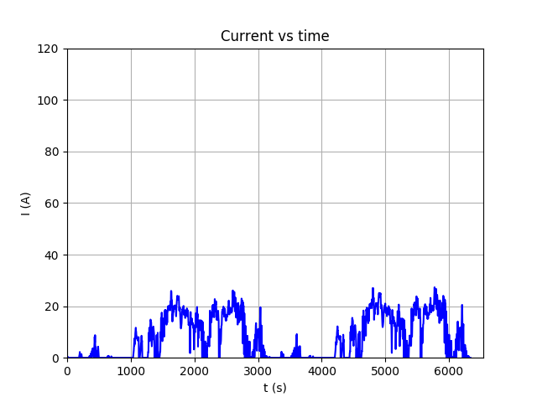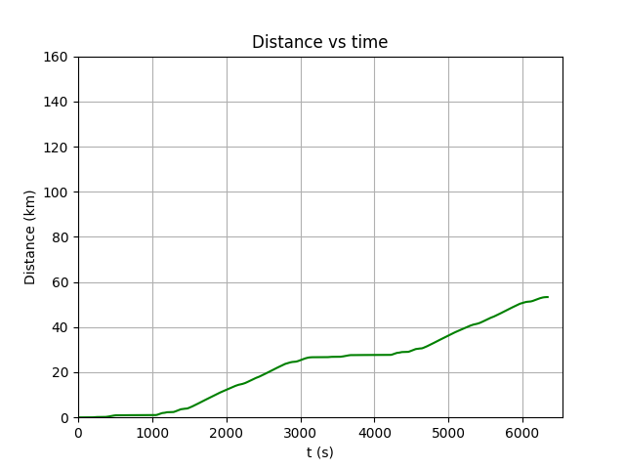

Inference:

* Peak speed in simulation : 108 kmph
* Peak power drawn : 11 kW
* Peak power for max acceleration : 27 kW
* Max Distance travelled: 156 km at 54 kmph constant speed
* Max Torque Required: 110 Nm
* Max Current drawn: 130 A
* Battery Pack Energy Capacity: 4kWh
* Battery Pack Voltage: 96V ( Based on motor sourcing)

**Battery Pack and**

**Thermal Management**

**1. Description**

A battery pack is a set of any number of (preferably) identical batteries or individual battery cells that may be configured in a series, parallel or a mixture of both to deliver the desired voltage, capacity, or power density to the given system.

Battery packs consist primarily of :

* cells in series and parallel configurations
* Electrical interconnects
* Protection Circuits
* Temperature sensors

Battery packs contains groups of cells in series and parallel wiring configurations which need to provide the desired voltage and amperage required for the system while taking into consideration the electrical balance of the circuit.

Battery packs often contain a temperature sensor and a protection circuit which the battery charger uses to detect the end of charging and regulate voltage and current values.

Battery management systems (BMS) are used to keep the voltage of each individual cell below its maximum value, monitor the State of Health(SoH),

State of Charge(SoC) and provide relevant feedback to the MCU.

**2. Specifications of the system**

Procedure:

* Based on the voltage and current requirements of the motor system, corresponding cell
* chemistries and configurations were analysed .
* 18650 form factor of Li-Ion (INR/NCA) cells were chosen to optimize safety and space constraints.
* Cell configurations:

LG HG2 (20A) -> 27S14P

Voltage : 96V

Amperage : 280A

Power : 26.8kW

Capacity : 4.08kWh

LG MH1 (10A) ->27S18P

Voltage : 96V

Amperage : 180A

Power : 17.2kW

Capacity : 5.5kWh

**3. Battery Pack**

**a. Battery chemistry**

| **Description** | LG HG2  3000mAh | LG MH1  3200mAh |
| --- | --- | --- |
| **Chemistry** | INR | NCA |
| **Voltage** | 3.6V | 3.6V |
| **Amperage** | 20A | 10A |
| **Advantage** | *High Power  *Increased safety  *Lowest self heating rate | *High capacity  *High energy density  *Good life span |
| **Disadvantage** | *Lower capacity  *Lower life cycle | *Marginal safety  *Increased cost |
| **Chart** | *source-Boston Consulting Group | *source-cadex |

Reference: http://batteryuniversity.com/learn/article/types_of_lithium_ion

**b. Pack topology**

Cells in a battery pack are generally arranged in 2 ways:

1. Cubic arrangement



* This arrangement provides even spacing between cells and is optimal for a passive (Air) cooled system.
* Cells can be easily placed within cell holders to form a uniform pack.
* Less contact between cells which reduces “Hot spots”

2. Nested arrangement

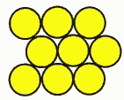

* Space optimized packing which reduces overall volume of the battery pack.
* Maximized cell contact which benefits heat transfer to cooling plates in an active (liquid) cooled system.

**4. Thermal Management**

**a. Cell housing**

* Cell housing provides the necessary reinforcement that the pack needs to withstand mechanical shock.
* Cell housing offers protection from contamination due to dust and moisture with may lead to electrical shorting.
* It also provides a means for thermal conduction from the modules to the cooling plates in a liquid system.
* Aluminium will the the preferred material for the casing over copper (higher thermal conductivity) as its is easier to form, lighter and cost effective.
* Advanced iterations of a cell housing for a modular pack can benefit battery swapping.

**b. Cooling solutions**

A high power pack with currents of over 200A generates large amounts of heat with can cause degradation of the cells due to uneven discharge cycles , hence it is essential to maintain optimum temperatures within the pack for peak performance and longer life cycle of the cells.

The Two most commonly used cooling systems are

* Air cooled (passive)
* Liquid cooled (active)

Air:

An air cooled system is a passive system that comprises of large heatsinks that carry heat from the cells to the surrounding air due to natural thermal gradient.

The air cooled system does not require additional power but large heatsinks add weight and volume to the overall pack while providing inferior cooling to a liquid cooled system.

Liquid:

A liquid cooled system is an active system that circulates fluid through a cooling plates that transfer heat from the cells to a radiator. Liquid cooled systems provide a uniform temperature across the pack and prevents the formation of “ Hot spots”.

Liquid cooled systems utilize a pump to circulate fluid through the cooling channels but provide increased cooling efficiency.

Inference:

The prototype of the E-Bike will utilize a air cooled system with no cell casing to provide ease of access and cost effectiveness.

The final model will feature active liquid cooling with ethylene glycol and aluminium radiators for increased battery performance and optimal volume by providing superior cooling capabilities.

References:

* <https://www.powerstream.com/BPD.htm>
* <http://batteryuniversity.com/learn/article/serial_and_parallel_battery_configurations>
* <http://americansolarchallenge.org/ASC/wp-content/uploads/2013/01/high_cell_count.pdf>
* <https://batterybro.com/products/lg-hg2-inr18650hg2-3000mah-20a>
* http://www.intersil.com/content/dam/Intersil/whitepapers/battery-management/li-ion-battery-pack-safety.pdf
* <https://drive.google.com/file/d/0BynEDbXLzTIlVEhxbTlkdmZQTE0/view>
* <http://sbs-forum.org/marcom/dc2/11_battery_pack_safety.pdf>

**Battery Management System**

**1. Description**

The objective of the battery management system is to monitor the battery characteristics and take safety measures when required. It passes on this information and stores it in the records.

We are using bq76940 as our IC for battery management. It uses I2C interface to communicate with the host controller. Using this IC, we can monitor the cell voltages, pack current and pack temperature. We can sense data on real time and take precautionary measures in extreme cases.

**2. Literature Review:**

1. Battery characteristics:

* Voltage is measured using an ADC(Analog to Digital Convertor). The analog value read is compared to a reference value to get the voltage reading.
* Internal ADC measures pack current.
* Temperature is calculated using a circuit containing a thermistor.

2. State of charge (SOC):

State of charge is like a fuel gauge in petrol or diesel engines. It describes the present battery pack conditions. It reports a value from “empty” (no charge left – 0%) to “full” (fully charged – 100%). It cannot be directly measured. There are a number of methods that can be used to measure SOC. Our method is all follows:

o Formula used:

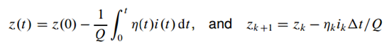

Where: z = state of charge at a given time

Q = capacity

i = current at a particular time

$η$ = coefficient/weight of charge

3. Cell Balancing:

Cell balancing is a method used to maintain a constant SOC over all the cells.We use passive cell balancing to remove excess charge present in cells by monitoring them continuously.

P channel MOSFETS are used, with the internal drivers of the IC allowing the FET’s to switch the cells into a simple resistive circuit, removing excess charge in the form of heat.

**3. BMS Functions**

* Monitor cell voltage, current and the pack temperature.
* Code to check if these characteristics are out of the required range.
* Cell balancing.
* SOC (state of charge) estimation.

Currently working on:

* Code for cell balancing.
* Code for SOC estimation.
* Programming Raspberry Pi to manage BMS and the motor controller.
* Using Raspberry Pi to display visuals of the data read by the BMS and the motor controller.

**4. IC and PCB**

We are using the IC bq76940 to monitor the cells. This IC can handle up to 15 series cells (48V packs). It has internal ADCs to measure cell voltage and pack current(coulomb counter) It supports up to 3 thermistors for measuring die temperature. It has protection features for detecting overcurrent, short circuit, overvoltage and undervoltage. Integrated cell balancing FETs are present for passive cell balancing.

Via I2C, a host controller can use the IC to implement many battery pack management functions, such as monitoring (cell voltages, pack current, pack temperatures), protection (controlling charge/discharge FETs), and cell balancing.

The BMS schematic was sourced from a pre-existing and proven design. It was originally designed by an individual known as N.Seidle, with the intention of using it to drive a low power electric bicycle. With the consideration of the higher powered motorcycle being developed, corresponding components were replaced to allow greater power and current draw.

Charge/Discharge MOSFETS were removed, with the intention of allowing the motor controller to control the discharge and the charging circuit to control the charge.

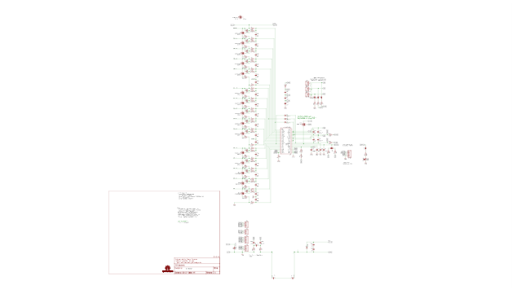

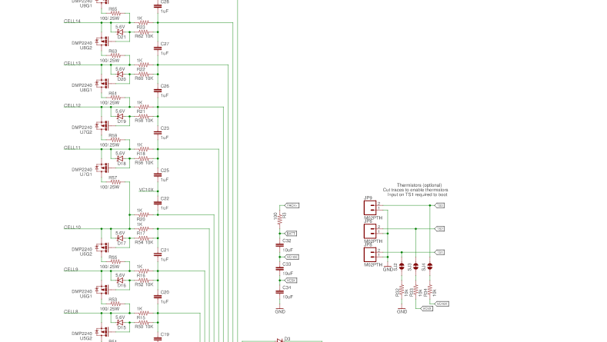

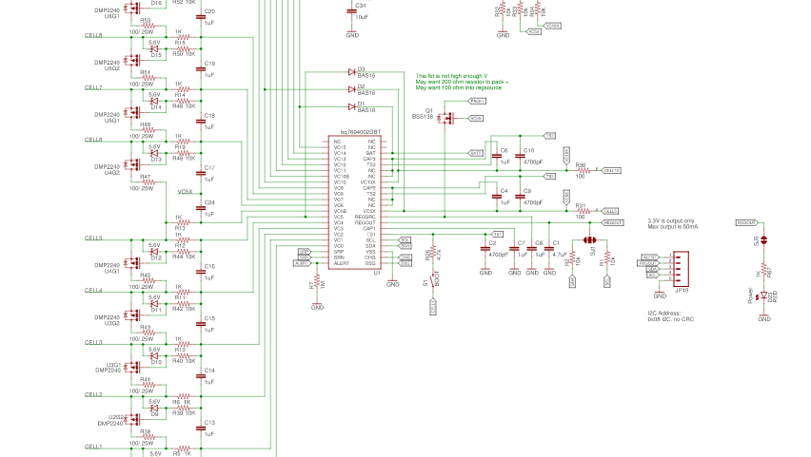

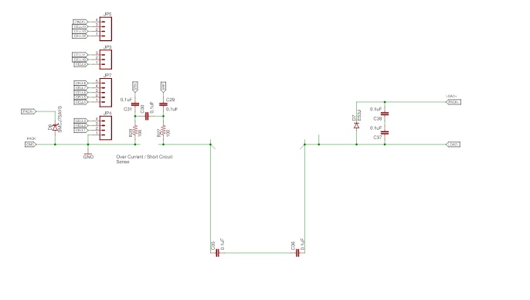

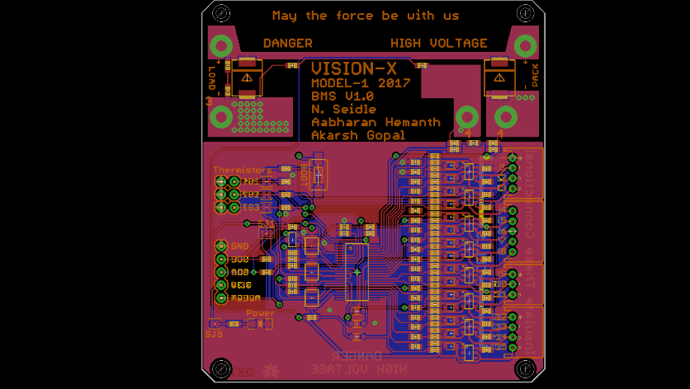

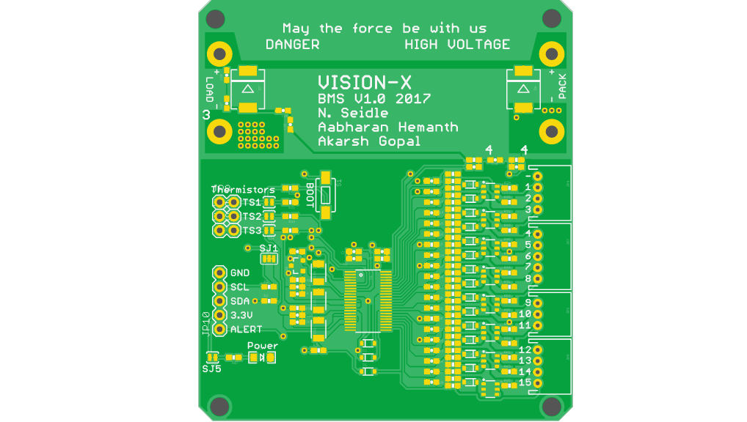

**5. References:**

* IC reference material : http://www.ti.com/product/BQ76940/
* BMS online course :<http://mocha-java.uccs.edu/ECE5720/index.html>
* Kalman filter course : http://mocha-java.uccs.edu/ECE5550/
* Header and Source code : https://github.com/LibreSolar/bq769x0_mbed_lib

**Charging System**

**Table of Contents**

1. Description
2. Literature Review
   1. Battery Charger
   2. Charging Rates
   3. Conclusion
3. Specifications of System
   1. Calculation of Specifications
   2. Specifications overview
4. Boost converter
   1. Parts and specifications
   2. Schematic
   3. PCB
5. Buck converter
   1. Parts and specifications
   2. Schematic
   3. PCB
6. References

**1.** **Description**:

The objective of the battery charger is to draw power from the AC mains ,convert it to the desired DC voltage and channel it to the battery. This must be done in the shortest possible time without damaging the battery.

The charger has been selected after a lot of literature study , we also spoke to the engineers at emflux motors, an electric motorbike company.The charging system here consists of 2 parts.

1. Boost converter with power factor correction.
2. Buck converter

* The boost converter consists of a rectifier, which converts AC to DC, the boost converter steps up the voltage from 220V to 350+V.
* Power factor corrector and a filter circuit is required to keep the grid isolated from the charger and to reduce wastage of power which is caused by the charger.
* The buck converter steps down the voltage to desired voltage to charge the batteries, the voltage varies with the CC-CV stage of charging.

**2. Literature Review**

1. **Selection of Converter**

Battery chargers are required to charge the batteries, in a certain period of time depending on the charging mode. Charging is stopped when the cells reach a particular voltage, for most Li-ion cells this voltage is 4.18V to 4.2V.

Detection of the voltage at which charging has to be stopped is very important, Li-ion cells are especially sensitive to overcharge .If the cells are overcharged, their lifespan is reduced significantly and the SOH is adversely affected.The TI BQ76940 IC monitors and controls charge termination.

Battery chargers are non-linear loads, they cause the current and voltage waveforms to be out of phase with the input waveforms. This phase difference reduces the power factor. A lower power factor results in inefficient use of power due to which power is wasted. Most battery chargers introduce noise into the system, higher the power, greater the noise, this can have a huge impact on the grid and may also cause the grid to collapse. To isolate the grid from the noise from the charge,r a filter circuit is used. A power factor corrector is used to keep the power factor as close to unity as possible.

Charging happens in two stages, Constant current(CC) and constant voltage(CV).

1. CC - This is the first stage of charging ,in this stage , the charging current is kept constant for a short while, after a certain period of time the charging current gradually drops.
2. CV - For most part of the charging , voltage is kept constant, the voltage becomes constant around the time the charging current starts to drop.When the cell voltage reaches 4.2V charging is terminated.

**b. Charging Rates**

Batteries can be charged at different rates. The rate of charging simply refers to the rate at which charge is put into the cell, it determines the speed at which the batteries are charged . The “C rate’’ is a measure of speed of charging.

C Rate * t = 60mins

Where t = time taken for charging (in minutes)

1. **Slow charge** - takes around 14-16 hours. This is the simplest method , the charger required is also very simple in construction. This method is rarely used to charge Li-ion batteries due to the long charging time and also because Li-ion cells can not tolerate being overcharged. This method is only used when the Li-ion cells is discharged to a voltage below 3V and needs preconditioning charge.
2. **Fast charge** - takes 60 - 80 mins. This method takes less time but presents the danger of overheating and overcharging and requires chargers that are more complex. There is generally no single charger that can be used for all types of batteries and requires specific chargers to be made for specific cell chemistries and capacity . A temperature cut off is required to prevent overheating and end point detection is very important.

**c. Conclusion**

While in most cases fast charging is required , charging the batteries around 0.5C should be done whenever possible , this helps extend battery life and performance.

**3. Specifications of System**

**a. The procedure for arriving at the specifications for the battery charging circuit**

**system was as follows:**

1. Look at various electric vehicle manufacturers’ charging system design.
2. Use the calculated results and refer to electrical engineering and electronics engineering material to calculate variations in said specifications across components and circuits.

**b. Specifications:**

* Input AC mains voltage : 240V
* Input frequency : 50-60 Hz
* Battery Voltage: 96V Nominal
* Battery Charge Current capability: 30A
* Charging Power: 3kW rapid charge

**4. Boost converter and power factor corrector**

**a.Parts and specifications:**

The Boost converter consists of a rectifier, boost converter and a power factor corrector. The specifications are as follows:

The calculations have been done according to the design guide

<http://www.infineon.com/dgdl/Infineon-ApplicationNote_PFCCCMBoostConverterDesignGuide-AN-v02_00-EN.pdf?fileId=5546d4624a56eed8014a62c75a923b05>

Inductor : 290uH , 25A +

Capacitor: 5.8mF , 450V+

**b.Schematic:**

The Driver circuit for the Charger is based on the UCC21520 MOSFET driver and the INA199 current sense amplifier both from Texas Instruments.

With reference to the selected architecture and parts, the schematic has been designed to follow the recommendations and guidelines of the said parts’ manufacturers and the norms of the architecture.

**c.PCB:**

A two sided PCB with copper pours where possible and parts are positioned allow better routing.The PCB has been laid out to minimise impedance and noise in the circuit by minimising track lengths and adding filter capacitors where necessary. The input and output ports are positioned to make it easy-to-use.

**5. Buck converter**

**a. Parts and specifications:**

The buck converter steps down the voltage from boost converter and

PFC.

The calculations for inductor , capacitor etc have been done using the

following guide

<http://www.ti.com/lit/an/slva477b/slva477b.pdf>

L =( Vo * (Vo - Vi)) / (Il * Fs * Vi)

If = Iom *(1-D)

Comin = Il / ( 8* Fs *Vo)

Inductor : 112uH +/- 5.56uH , 30A

Capacitor : 1.8uF +/- 0.09uF , >250V

Schottky Diode : IF  >30A , Vrrm >250V

**b. Schematic:**

The Driver circuit for the Charger is based on the UCC25120 MOSFET driver and the INS199 current sense amplifier both from Texas Instruments.

With reference to the selected architecture and parts, the schematic has been designed to follow the recommendations and guidelines of the said parts’ manufacturers and the norms of the architecture.

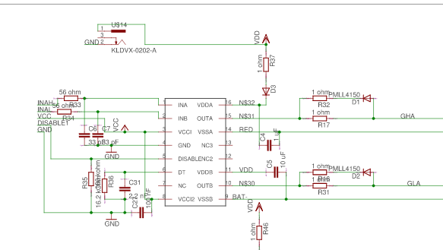

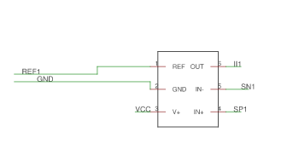

**c.PCB:**

A two sided PCB with copper pours where possible and parts are positioned allow better routing. The PCB has been laid out to minimise impedance and noise in the circuit by minimising track lengths and adding filter capacitors where necessary. The input and output ports are positioned to make it easy-to-use.

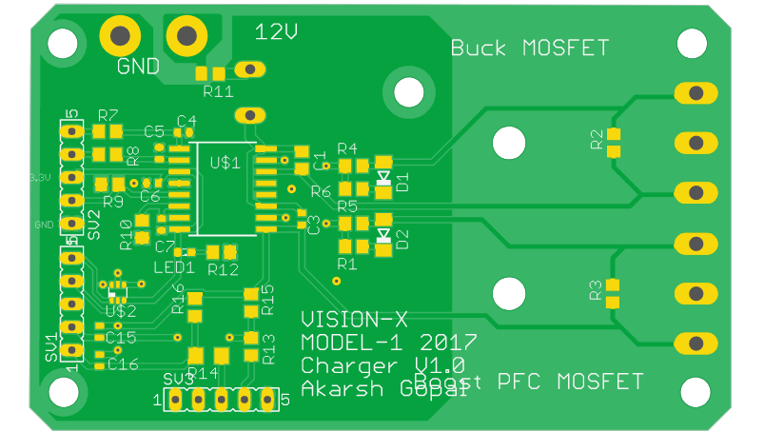

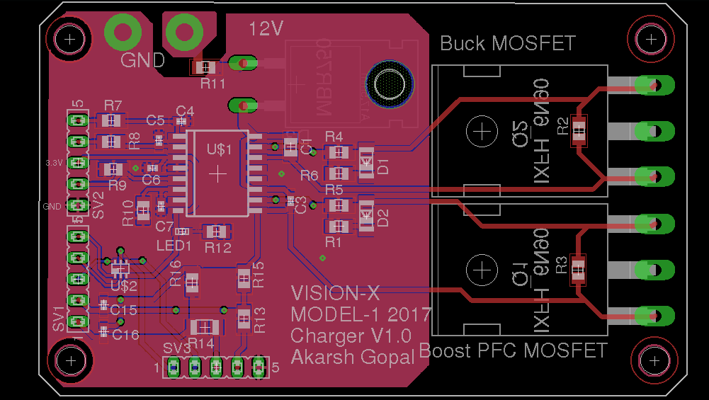

**7. References**

1. <http://www.infineon.com/dgdl/Infineon-ApplicationNote_PFCCCMBoostConverterDesignGuide-AN-v02_00-EN.pdf?fileId=5546d4624a56eed8014a62c75a923b05>
2. <http://www.ti.com/lit/an/slva477b/slva477b.pdf>
3. <http://www.mpoweruk.com/chargers.htm>
4. <https://blog.atherenergy.com/the-charger-challenge-c8042fef252e>
5. <https://en.wikipedia.org/wiki/Total_harmonic_distortion>
6. <http://www.mpoweruk.com/life.htm#rate>
7. <https://www.allaboutcircuits.com/technical-articles/how-the-boost-pfc-converter-circuit-improves-power-quality/>
8. <http://www.upsbatterycenter.com/blog/use-power-factor-correction-battery-chargers/>
9. <https://en.wikipedia.org/wiki/Tesla_Supercharger>
10. <https://slack-files.com/files-pri-safe/T4GHERYTH-F5Z29EVPW/dc-dc_modelling.pdf?c=1498407528-6f499b90e271ed41231ca71c17c51f75e9bac004>
11. <https://slack-files.com/files-pri-safe/T4GHERYTH-F5YE1QHR7/slyt584.pdf?c=1498407801-8b5b8eb6a07564ec5943c6b426be636855a65438>

**Motor and Controller Design**

**1. Description:**

The objective of the motor controller is to take the throttle input from the user, the current state of rotation of the motor, and to manipulate the voltage and current from the battery in order to provide sufficient torque to bring the motor speed to that required by the user.

The propulsion device selected for this particular application after thorough literature study and analysis, is the 3 phase AC Induction Motor.

The controller must switch the DC of the battery to 3 phase AC power according to the throttle input. Hence the controller system is divided into three:

1. Inverter
2. Driver
3. MCU(Microcontroller)

Where,

* The inverter consists of Electronic switching devices that oscillate in PWM between states to control amplitude and frequency of the Voltage and Current fed to the motor.
* The driver circuit functions as an intermediate between the Inverter and the MCU, allowing for logic level shifting and signal conditioning in order to safeguard the MCU from the immense power levels of the inverter.
* The MCU functions as the brain of the controller, using feedback loops and external inputs to control the power being fed to the motor.

**2. Literature Review**

**a.Selection of Motor**

Electric Motors are classified mainly as:(i)DC and (ii)AC.

Literature study suggests that while both are highly efficient, the exact application of the motors causes a minor difference in the efficiency.

Factors such as torque/power requirement, range of speed, and mechanical stress affect the performance of the motor. After significant research, BLDC and 3 phase AC induction motors were the top two choices for use in electric motorcycles. Due to the significant cost of BLDC motors at the performance level necessitated in this particular application and factors such as magnetic hysteresis and magnetic losses in BLDC motors, the AC induction motor was chosen as our primary option.

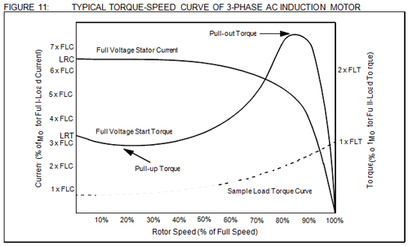

Courtesy: http://www.lhp.co.in/index_without_right.php?file=motor_school

Links:

<https://drive.google.com/file/d/0BynEDbXLzTIlVEhxbTlkdmZQTE0/view?usp=sharing>

<https://forums.tesla.com/forum/forums/ac-induction-motor-why>

**b.Controller topology**

With reference to the chosen motor, DC power must be converted to AC, and it is efficiently done by a Field Oriented Control DC/AC inverter drive as research suggests.This implies a frequency controller 6 step inverter

that takes feedback from the motor and the user.

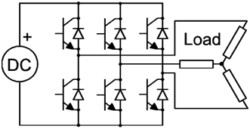courtesy:<http://www.ni.com/tutorial/14674/en/>

References:

Texas Instruments Motor Control Solutions( link at the end)

Wikipedia:<https://en.wikipedia.org/wiki/Variable-frequency_drive>

M.Paul Holmes: <http://www.instructables.com/id/200kW-AC-Motor-Controller-for-Electric-Car/>

**c.Conclusion**

The chosen power-train is as follows:

* Li-ion Battery - Energy Source
* 3 Phase AC induction Motor - Propulsion Device
* 6 step DC/AC inverter VFD drive.

**3. Specifications of System**

**a. The procedure for arriving at the specifications for the controller system was**

**as follows:**

1. Survey market for favourable specifications of “performance motorcycle”.
2. Use said specifications to simulate powertrain requirements.
3. Use said simulation results to calculate voltage, current and power requirements of controller system in question. Link to simulation results: <https://docs.google.com/presentation/d/10klwxDaheX3qn5t4FTHrWJLxYVPgGmT3ozpBiqA57yM/edit?usp=sharing>
4. Use the calculated results and refer to electrical engineering and electronics engineering material to calculate variations in said specifications across components and circuits.

**b. Specifications:**

* Input Voltage(Battery): 96V DC
* Input Current max( from battery specs): 200 A
* Output Voltage RMS(from selected motor;dependant on source): 96 VDC / 64V AC per phase
* Output Current peak( from simulation Motor current): 130 A
* Max Power through system: 21.6 kW

**4. Inverter**

1. **Parts and specifications:**

The inverter is composed of 6 switches that are driven by PWM outputs from the MCU( level-shifted by driver). The specifications of these are as follows:

* Max Current: > 200A
* Max reverse breakdown voltage: >120V
* Switching Speed: > 10 kHz
* Gate Drive Voltage: <15 V

Among MOSFETs and IGBTs, MOSFETs were chosen as suitable for the above specifications as they generally had a higher performance/cost ratio for the same.

In order to reduce part costs and improve repairability of the system, the parallel

MOSFET configuration was used, since this reduces current requirements for the MOSFEts.Upon Applying above constraints to our search, the part: **IRFP4568PbF** (TO-237 form factor) from manufacturer International Rectifier was selected as optimum.(datasheet in folder)

The remainder of the Inverter System consists of secondary passive components which are based on the requirements of the IRFP4568PbF MOSFET and its application topology.

**b. Schematic:**

The Inverter circuit is based on the 3 phase inverter design, however, it has been modified to accommodate 2 MOSFETs in parallel for each of the high side/low side switches. Gate to source resistors have been sized and placed in order to clear out residual charge from the capacitive gate junctions. It includes current sense resistors as well.

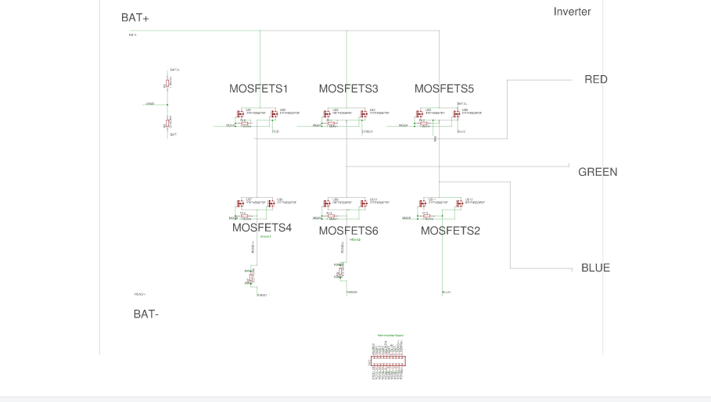

**c. PCB:**

The PCB for the inverter has been designed to allow PWM input ports from the driver board, Vcc and GND. Output ports include Current and voltage sense pins. The remainder of the board consists of the 12 MOSFET switches.

Note: Schematic and PCB documents are available in the folder.

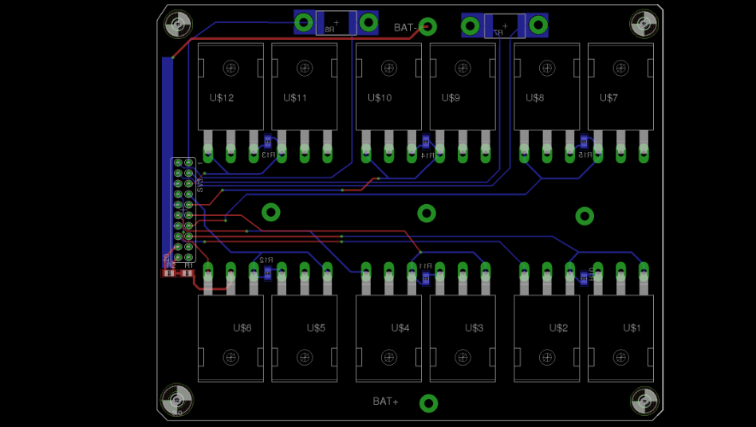

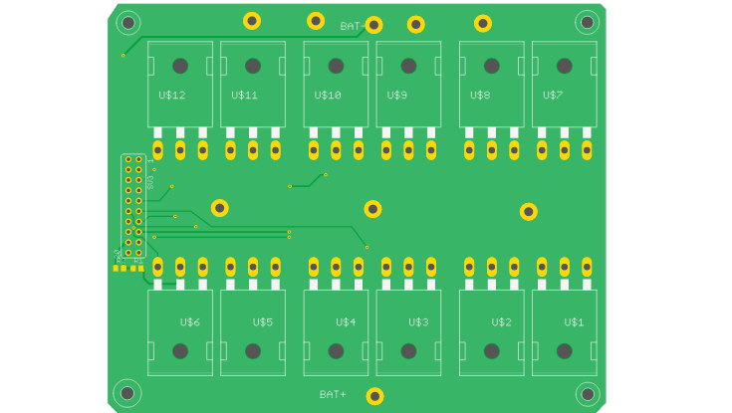

**5. Driver**

**a. Parts and specifications:**

In reference to the inverter design, the requirements of the driver is as follows:

* Amplify current sense inputs ( from order of uV to mV)
* Normalize voltage sense inputs ( from order of V to mV)
* Step up PWM signals from MCU( 3.3V logic) and output it to inverter MOSFETs (12V)
* PWM output to MOSFET gate must be ~12V
* Current capability of PWM out at 3A peak.

In order to minimise parts count and associated costs, an integrated solution was chosen for the drive circuit , such that multiple(2) MOSFET’s could be driven using one part. Same method was applied to current sense amplifier. Parts selected based on the same are: UCC21520 from Texas Instruments and INA199 also from Texas instruments

**b. Schematic:**

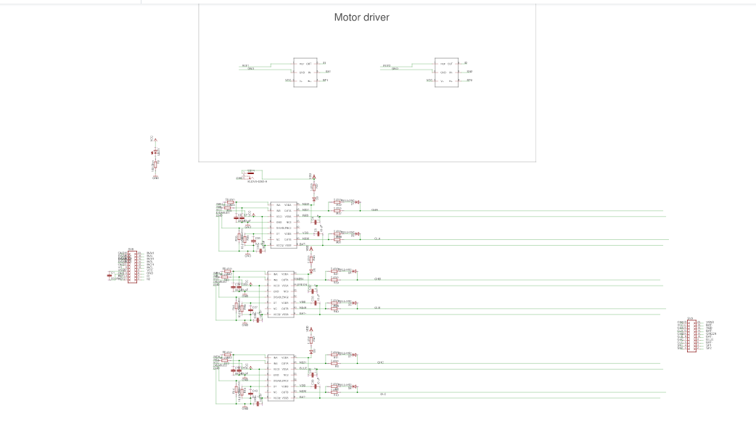

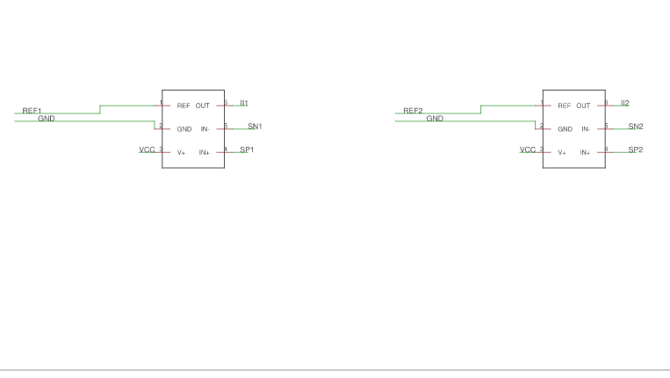



The Driver schematic has been designed such that PWM inputs from the MCU are stepped up by the UCC21520 to 12V required by inverter MOSFET gates for peak conduction. The current and voltage sense signals from the inverter are conditioned by the INA199.

**c.PCB :**

The PCB is designed keeping tolerances and trace widths in mind, while simultaneously minimizing impedance and noise by placing filter capacitors close to devices and minimizing trace lengths where possible.

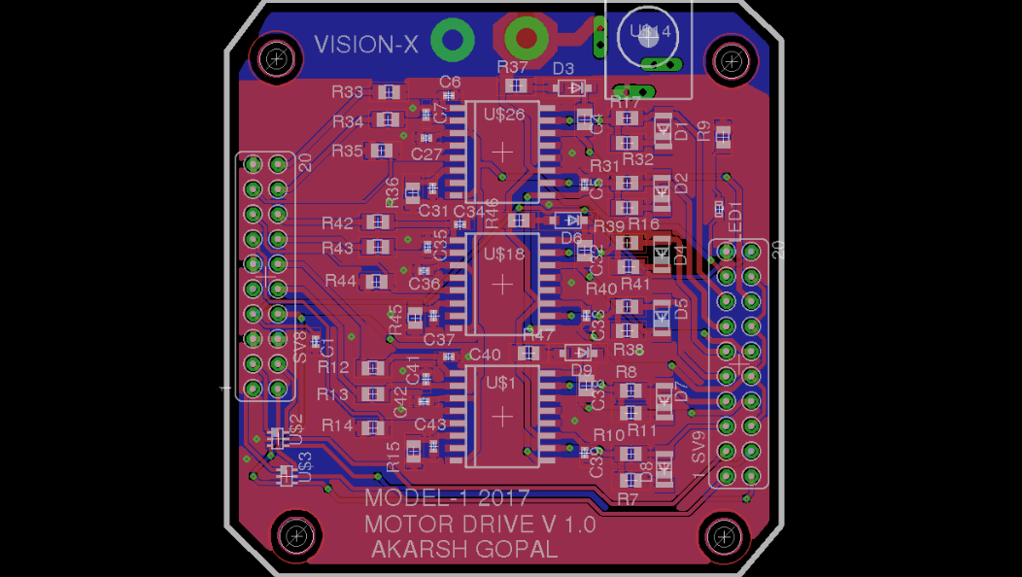

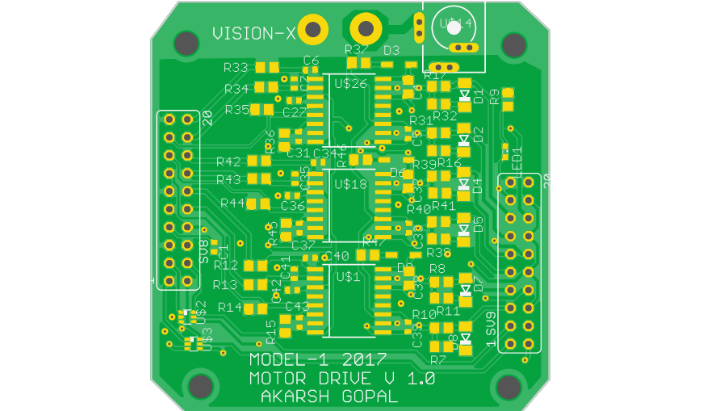

Note: Schematic and PCB documents are available in the folder.

**6. MCU**

**a.Part, specifications and source:**

Constraints posed by the above two systems helped narrow down the search for an MCU as follows:

* PWM capability : >6 channels
* Analog input : >5 AIO pins.
* PWM frequency: >10 kHz
* Clock speed: >1 MHz
* Capable of solving complex math within microseconds.
* Communication protocol: SPI / I2C

This resulted in selection of TMS320F28069 Launchpad from Texas Instruments as the MCU platform since it is a plug and play solution minimising application design time and costs, and speeding up development and testing.

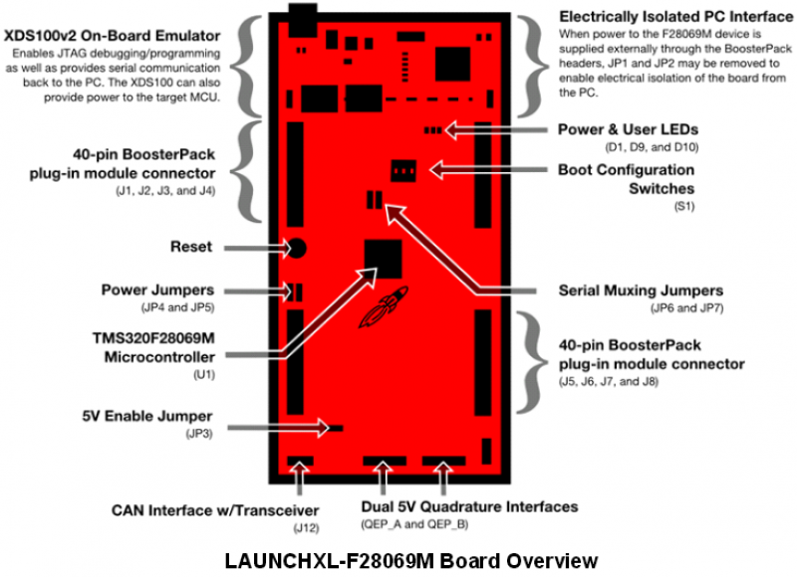

Image courtesy: Texas Instruments

**7. References**

1. <https://learn.sparkfun.com/tutorials/using-eagle-board-layout>
2. <https://artofelectronics.net/>
3. <https://www.electrical4u.com/concept-of-power-electronics/>
4. <http://www.powerelectronics.com/>
5. <https://www.tesla.com/about/legal#patent-list>
6. <http://www.instructables.com/id/200kW-AC-Motor-Controller-for-Electric-Car/>
7. <http://www.mpoweruk.com/>
8. <https://www.brammo.com/>
9. <http://torkmotorcycles.com/>
10. <http://www.electroschematics.com/444/motor-speed-regulator-with-triac/>
11. <https://en.wikipedia.org/wiki/Pulse-width_modulation>
12. <http://www.ti.com/general/docs/lit/getliterature.tsp?baseLiteratureNumber=slyb165>
13. <http://processors.wiki.ti.com/index.php/TMS320C2000_Motor_Control_Primer>
14. <http://www.ti.com/lit/an/sprabp8/sprabp8.pdf>
15. <http://www.ti.com/lit/an/sprabq3/sprabq3.pdf>
16. <http://www.ti.com/lit/an/bpra073/bpra073.pdf>
17. <http://www.ti.com/lit/an/spra588/spra588.pdf>
18. <http://www.ti.com/general/docs/lit/getliterature.tsp?baseLiteratureNumber=SLUSCJ9&fileType=pdf>
19. <http://www.ti.com/lit/ds/symlink/ina199.pdf>
20. <http://www.ti.com/general/docs/lit/getliterature.tsp?baseLiteratureNumber=sprs698>
21. <http://www.ti.com/tool/LAUNCHXL-F28069M>